**Problem 1**: Linear Regression

You are hired by a company Gem Stones co ltd, which is a cubic zirconia manufacturer. You are provided with the dataset containing the prices and other attributes of almost 27,000 cubic zirconia (which is an inexpensive diamond alternative with many of the same qualities as a diamond). The company is earning different profits on different prize slots. You have to help the company in predicting the price for the stone on the bases of the details given in the dataset so it can distinguish between higher profitable stones and lower profitable stones so as to have better profit share. Also, provide them with the best 5 attributes that are most important.

**Data Dictionary:**

|  |  |
| --- | --- |
| **Variable Name** | **Description** |
| Carat | Carat weight of the cubic zirconia. |
| Cut | Describe the cut quality of the cubic zirconia. Quality is increasing order Fair, Good, Very Good, Premium, Ideal. |
| Color | Colour of the cubic zirconia.With D being the best and J the worst. |
| Clarity | cubic zirconia Clarity refers to the absence of the Inclusions and Blemishes. (In order from Best to Worst, FL = flawless, I3= level 3 inclusions) FL, IF, VVS1, VVS2, VS1, VS2, SI1, SI2, I1, I2, I3 |
| Depth | The Height of a cubic zirconia, measured from the Culet to the table, divided by its average Girdle Diameter. |
| Table | The Width of the cubic zirconia's Table expressed as a Percentage of its Average Diameter. |
| Price | the Price of the cubic zirconia. |
| X | Length of the cubic zirconia in mm. |
| Y | Width of the cubic zirconia in mm. |
| Z | Height of the cubic zirconia in mm. |

1. Read the data and do exploratory data analysis. Describe the data briefly. (Check the null values, Data types, shape, EDA). Perform Univariate and Bivariate Analysis.

Lets first load data,

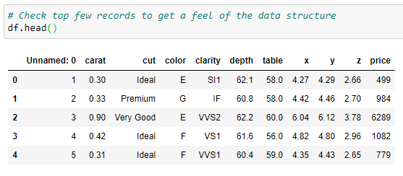

As we can see,

* Total 26967 records with 11 attributes.
* Attributes ‘cut’, ‘color’ and ‘clarity’ seem categorical/object in nature.
* Attributes ‘carat’, ’depth’, ’table’, ’x’, ’y’, ’z’, ’price’ seem numerical/float64 in nature.
* Dataset don’t hold any null values

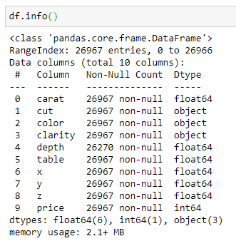

* Dataset description is as below, all attribute seem almost normal distribution

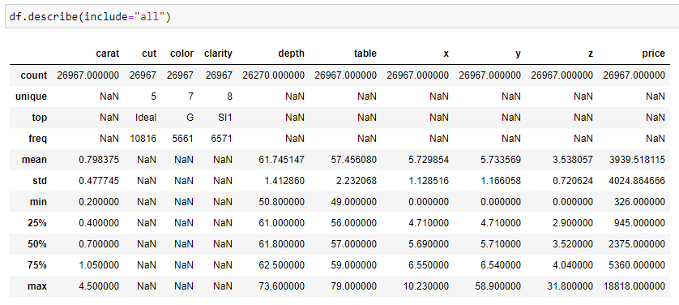

* Dataset contains 697 missing values for attribute ‘depth’

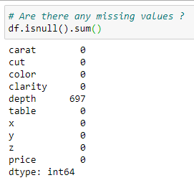

* Dataset contains 34 duplicate values

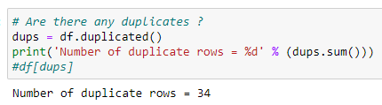

* Lets explore data correlation,
  + ‘price’ is highly correlated with ‘x’, ’y’, ’z’ and ‘carat’

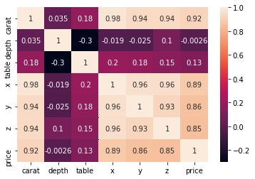

* Lets see data histogram
  + ‘carat’ , ‘price’, ‘y’ and ‘z’ seem highly left skew
  + ‘depth’, ‘table’, ‘x’ seem follow distribution

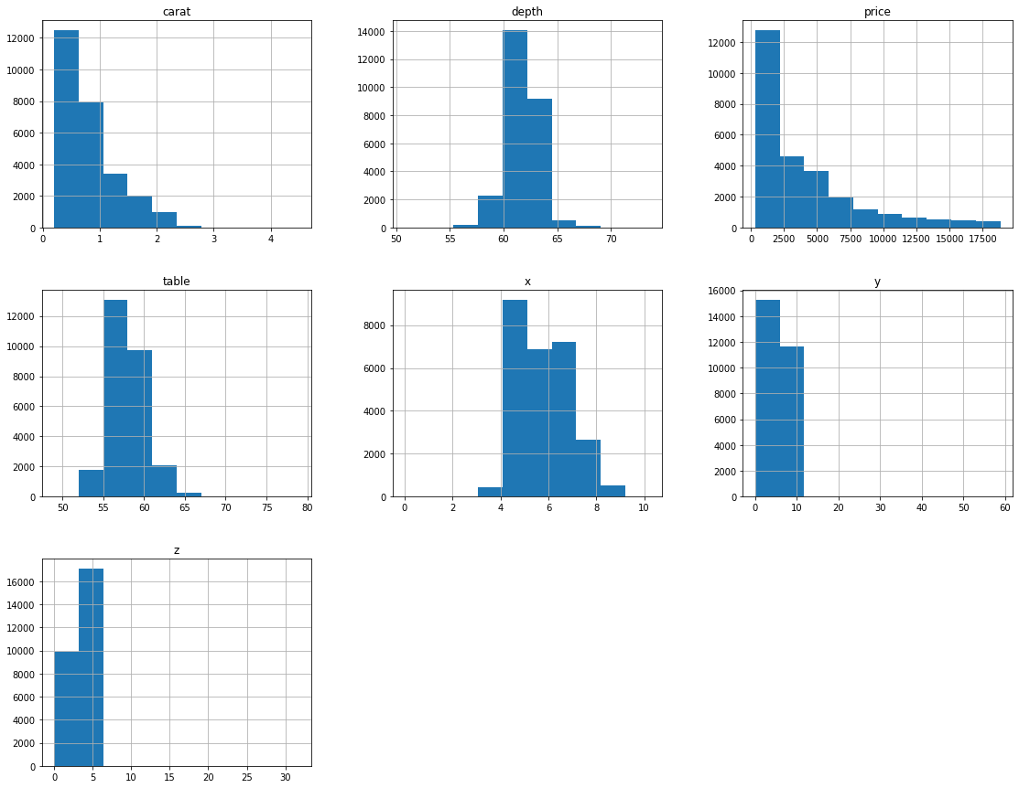

1. Impute null values if present, also check for the values which are equal to zero. Do they have any meaning or do we need to change them or drop them? Do you think scaling is necessary in this case?
2. Encode the data (having string values) for Modelling. Data Split: Split the data into test and train (70:30). Apply Linear regression. Performance Metrics: Check the performance of Predictions on Train and Test sets using Rsquare, RMSE.
3. Inference: Basis on these predictions, what are the business insights and recommendations.

Dataset for Problem 1: [cubic_zirconia.csv](https://olympus.greatlearning.in/courses/13599/files/1846357/download?wrap=1)

**Problem 2:** Logistic Regression and LDA

You are hired by a tour and travel agency which deals in selling holiday packages. You are provided details of 872 employees of a company. Among these employees, some opted for the package and some didn't. You have to help the company in predicting whether an employee will opt for the package or not on the basis of the information given in the data set. Also, find out the important factors on the basis of which the company will focus on particular employees to sell their packages.

**Dataset for Problem 2:** [Holiday_Package.csv](https://olympus.greatlearning.in/courses/13599/files/1846360/download?wrap=1)

**Data Dictionary:**

|  |  |
| --- | --- |
| **Variable Name** | **Description** |
| Holiday_Package | Opted for Holiday Package yes/no? |
| Salary | Employee salary |
| age | Age in years |
| edu | Years of formal education |
| no_young_children | The number of young children (younger than 7 years) |
| no_older_children | Number of older children |
| foreign | foreigner Yes/No |

1. Data Ingestion: Read the dataset. Do the descriptive statistics and do null value condition check, write an inference on it. Perform Univariate and Bivariate Analysis. Do exploratory data analysis.
2. Do not scale the data. Encode the data (having string values) for Modelling. Data Split: Split the data into train and test (70:30). Apply Logistic Regression and LDA (linear discriminant analysis).
3. Performance Metrics: Check the performance of Predictions on Train and Test sets using Accuracy, Confusion Matrix, Plot ROC curve and get ROC_AUC score for each model Final Model: Compare Both the models and write inference which model is best/optimized.
4. Inference: Basis on these predictions, what are the insights and recommendations.